**What is a URL?**

URL stands for Universal Resource Locator, and is the path to a unique resource on the Web. A URL points to a unique resource such as HTML documents, images, CSS files, etc. However, there are cases that a URL points to an empty location or the resource is missing.

**URL Structure**

A URL is composed of different parts; some of them are mandatory and others, optional. The mandatory parts are the protocol and domain name. The optional parts are the port, path to file, parameters and the anchor.

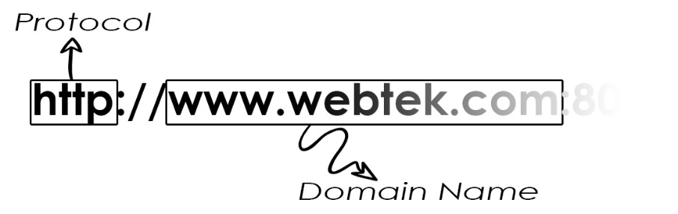

Protocol – Indicates what the browser must use. It is the first part of the URL. In the modern browsers, the user does not need to type the protocol; the browser automatically includes the protocol.

Domain Name – Indicates the web server that is being accessed. It is also possible to use the IP address of the web server. However, the domain name is preferred because people do not want to remember numbers.

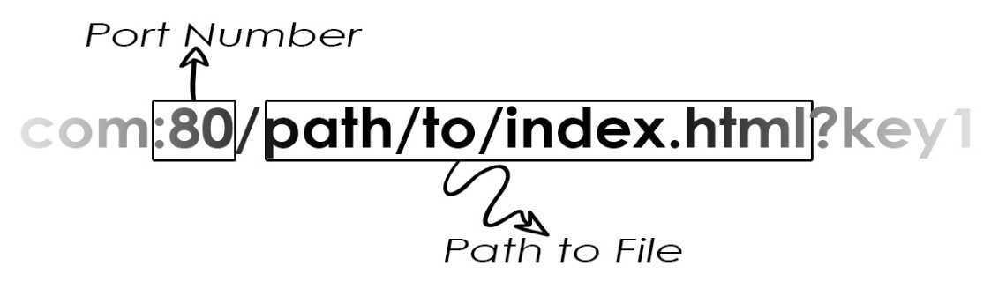

Port Number – It indicates what port or “gate” used to access the resource on the web server. The standard port of the web servers are 80 for HTTP and 443 for HTTPS. The port number is usually omitted. When the port numbers are other than 80 or 443, the port number is mandatory.

Path to file – This is the path to the specific resource on the Web Server.

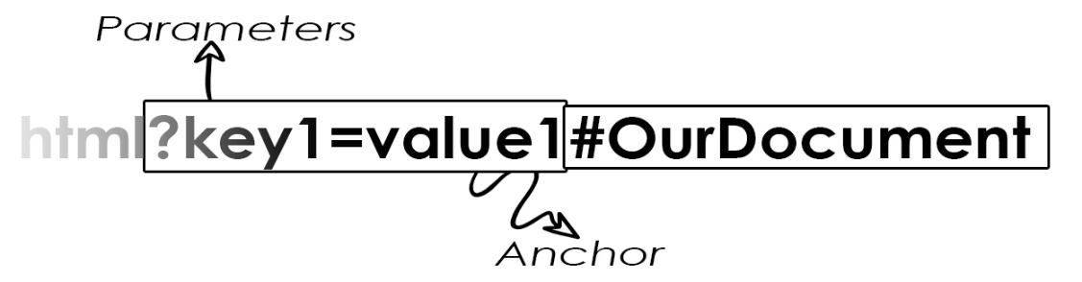

Parameters – It is a list of key-value pairs separated by the “&” symbol. The parameters start with the “?” symbol to indicate that the start of parameters.

Anchor – It acts as a bookmark for a page, and is another part of the document itself.